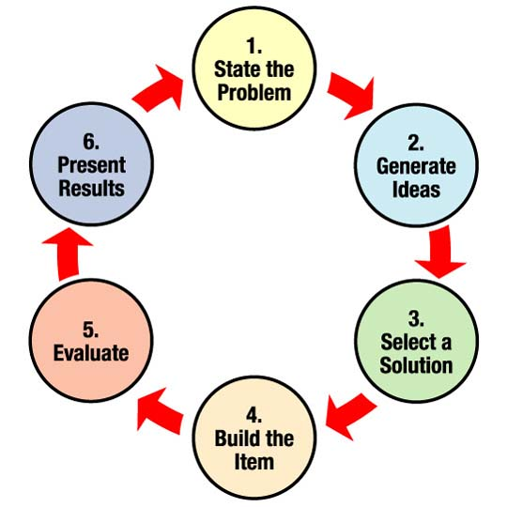
Engineering Design Process
Pre-Assessment

Directions – Use the word bank to fill in the blanks for each statement/question.
brainstorming | communicate results | defining the problem
design | final | improving design
process | research | systematic
test and evaluate | I don’t know
1. Design is a creative that allows people to realize their dreams and ideas to improve their lives.
2. Engineers and designers use a method of solving problems called the design process.
3. The first step in the design process is .
4. The last step in the design process is .
5. The design process is never ; there are always multiple solutions to a problem.
6. involves bringing a group of people together to generate many different ideas.
7. Asking questions of the “experts” is included in the part of the design process.
8. Checking that it meets the criteria and constraints is part of the
step in the design process.
9. There is no perfect .
10. requires detective work. You must examine the evidence and form some conclusions.
Answer the following two questions based on the given information:

Two students were talking about how to mix materials to make a good play dough. One student said they could mix flour and water. The other student said they could mix salt, flour, and water. After more collaboration, they came up with even more ideas.

A. Which step of the Engineering Design Process do you think they were working on? Explain your reasoning.

B. Which step of the Engineering Design Process would be best to do next? Explain your reasoning.

